# Kenneth Mead CSI-3670-14117.202110

# Lab 5 IIS/MSSQL

**Questions**

1. What are two differences (**other than cost**) between SQL Server and SQL Server Express Edition?

Express has more memory restrictions, in addition to less services. For example, express does not include the service for transaction management, db recovery, or encryption.

1. What is a default website in IIS? If you wanted to create a new default website (not using the existing default website), what steps are required to do so?

It is a welcome page in quite a few different languages. Run” inetmgr” in the “Run” window and select the “Default document” button to choose what is displayed by default.

1. Describe the differences between Digest, Forms, and Windows authentication for IIS applications/sites.

A digest is a way for IIS to authenticate users. A form is a way for users to send information. Windows authentication is a way for IIS to authenticate users through AD. This way they do not need to provide any credentials a second time.

1. What is an application pool?

An application pool is all of the processes running that communicate with the IIS web server. Examples are YAF and the .NET framework apps used to compile the web content.

1. Assume that you wanted IIS to run PHP pages. What would you have to do in order to serve PHP content?

Add the PHP windows extension. Add PHP as a module mapping in the IIS manager by going to

Handler Mappings -> Action panel -> Add Module Mapping -> “*.php“ in Request path

Add the full path to the PHP executable in the Executable box.

Add the PHP app to the IIS web server. In the IIS manager, right-click on Sites and then Add Website. In the Physical Path box, enter the absolute path to the PHP website.

1. Create some subforums on your wiki and screenshot them. Make a sample post and screenshot that too.

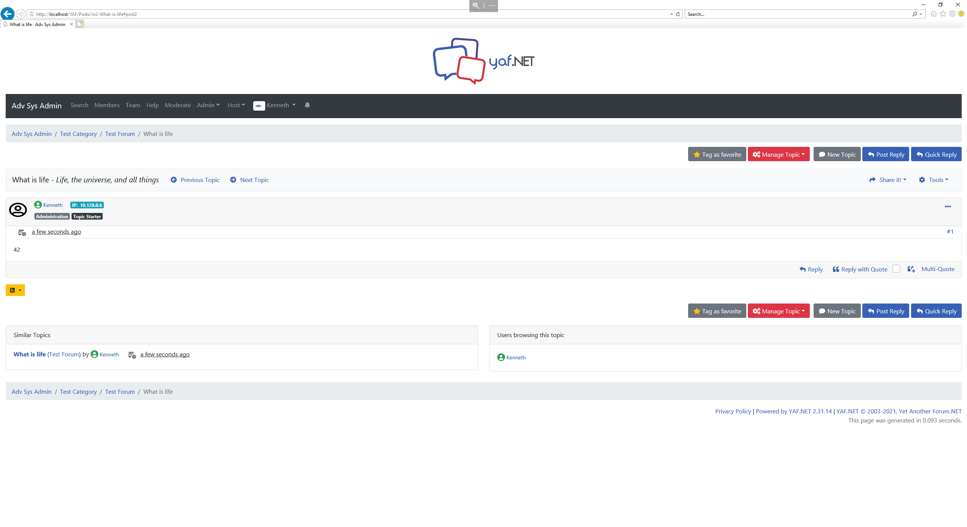

1. Make sure all screenshots asked for (two from the lab walk-through, plus the two from Question 6) are pasted here.

**Screenshots**

